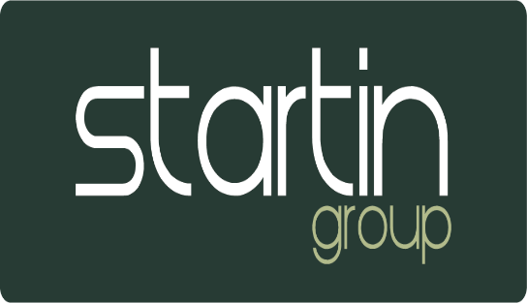

New supplier request

Authorising Limits
New suppliers, who’s annual expenditure is expected to be above a certain monetary threshold, require sign-off.
Up to £1,000 – Head of Business
£1,101 - £5,000 – Brand Director / Head of Group Accounts
£5,001 and above – Operations Director and Managing Director
Process
New suppliers are subject to further checks and evidence that the pre-existing suppliers upon the preferred supplier list have been consulted before new contracts are drawn up.
Startin Group outsource our procurement to Purchase Direct. For new suppliers or to request a change in suppliers Purchase Direct should be consulted with initially. Startin group also have internal resources for any electrical or site maintenance.
Please contact Stacey Arnold for a current suppliers list.
The group electrician Rob Hands can be contacted on 07712 705148
The group site maintenance can be arranged via Jim Bertram based at our Vauxhall site.
Supplier checklist:
Please ensure that the following is considered before progressing:
- The supplier is not duplicating the work of a pre-existing vendor.
- The supplier can deliver promised goods or services.
- The suppliers pricing is competitive and in line with other quotations received
- The service provided by the supplier cannot be performed by our own internal electrician and site maintenance personnel
- The supplier has strong sustainability credentials.
Before any contractual agreement is arranged the new supplier must complete the Startin Group ‘New Supplier Request form’
This will be authorised by the relevant person/s and passed to the accounts dept. to process.
The supplier will then be added to the organizational list of suppliers

