Kerridge – authorising Invoices (KOFAX Scanned docs)
This is a guide to explain how to authorise invoices on Kerridge:
- From the Kerridge main menu select Purchase Ledger and the company number relevant to your site:
- Startin Group = Skoda
20. Thomas Startin Junr. Ltd = Honda/Redditch/SOW
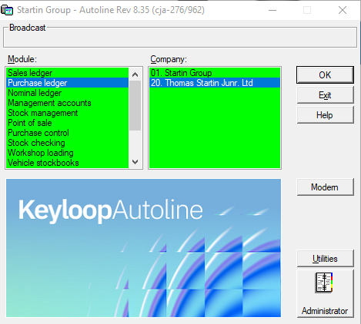

- In the following menu select ‘invoice scanning’ (bottom option on most users menu)
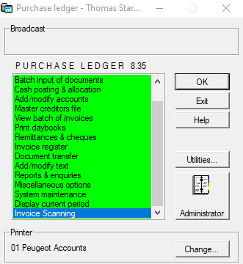
- Select ‘Authorise Invoices’
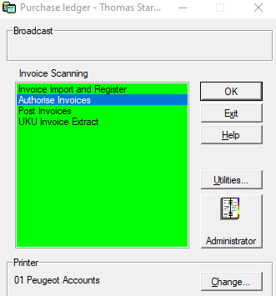

- Use pin number ‘9999’
- The next screen will contain all invoices that need authorising. Look for your user ID, right click on the line, a box will appear saying ‘authorise’, click this box.
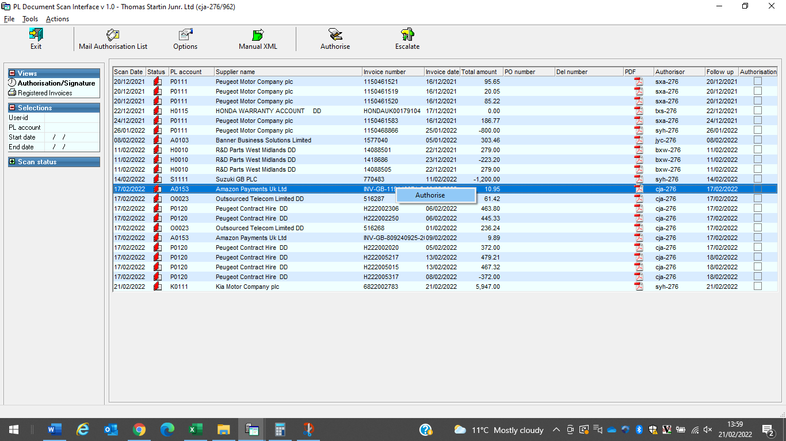

- To view the invoice click on the PDF button (you can also view the invoice on the previous screen by clicking on the PDF icon). If you are happy with the invoice click authorise. This will allow you to key into the ‘suggested NL’ & ‘additional text’ box (these are the only boxes you need to use). See last page of instructions on what to put in these boxes.
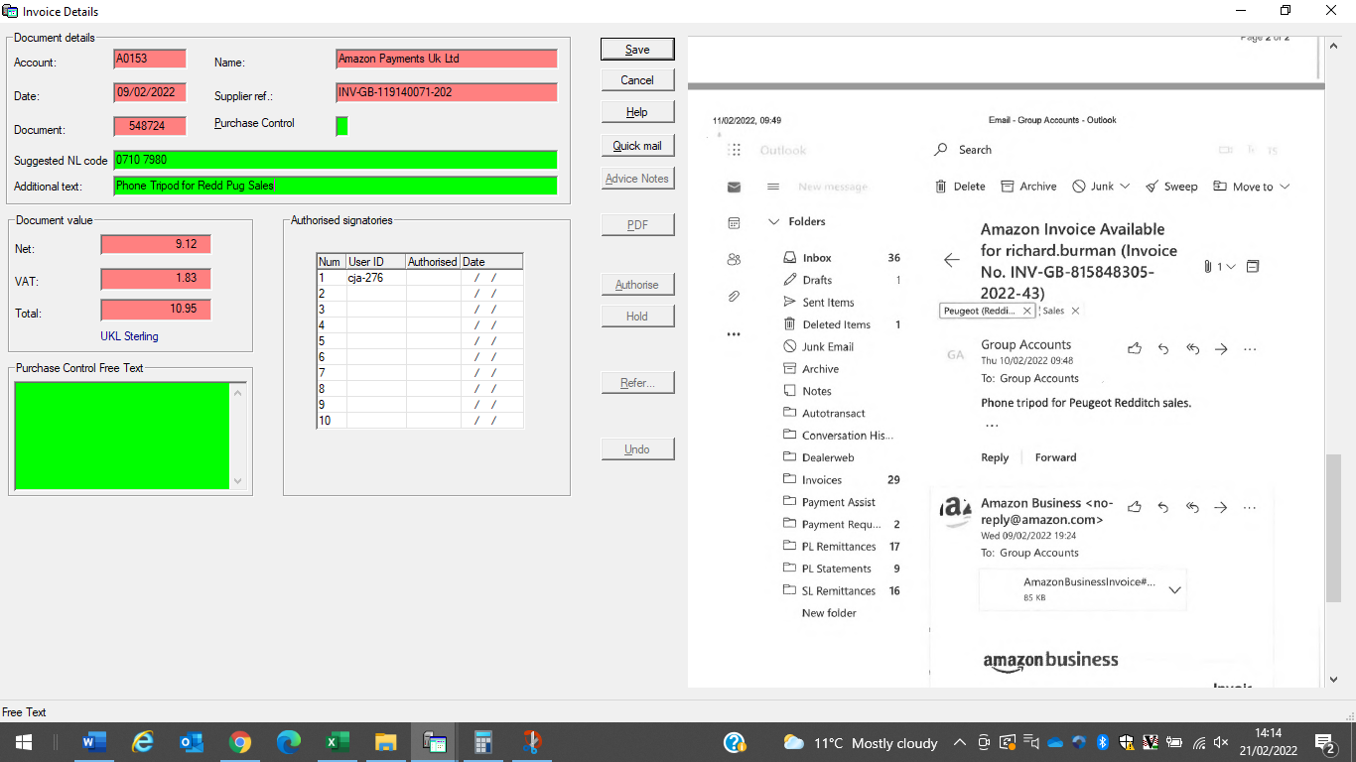

- Click save – your invoice has been authorised ready for Purchase Ledger to pull through to system.

- You can use the refer function if the invoice is not for you. Click on refer (click ‘ok’ if you get message about ‘unable to open file’) enter the persons id that you want to refer it to in the white box and put the reason in ‘referral reason’ box.

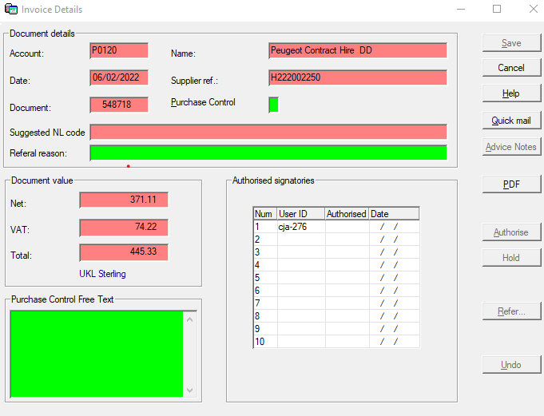

- Alternatively if you have query with a supplier on the invoice and need to put it on ‘Hold’, click the hold button and fill in the ‘withheld message’ box so Purchase Ledger know why the invoice cannot be authorised.

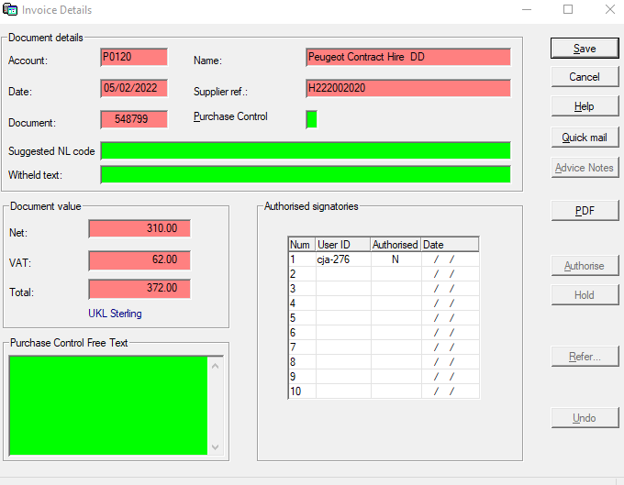

‘Suggested NL’ instructions

Dept | Description of item | enter into 'Suggested NL code' box
SALES | Invoice is for an item that has a line on the vehicle ie - accessory, re-con, etc | VSB + stk no.
SERVICE | Sub-con work | PO No. xxxxxx
 | Consumable item/s | Consumables
 | Small/loose tools | Small tools
PARTS | Anything outside of normal verification?
INDIRECTS | Work done to site | Building Maintenance
 | Fuel | Dept Fuel (email breakdown to Purchase Ledger)
 | Valeting | Dept Valeting (email breakdown to Purchase Ledger)

Any further instructions such as splits of the total invoice you can put into the ‘additional/IR text’ box or if there is not enough room put in ‘additional/IR’ text box ‘emailed PL with split instructions’.

