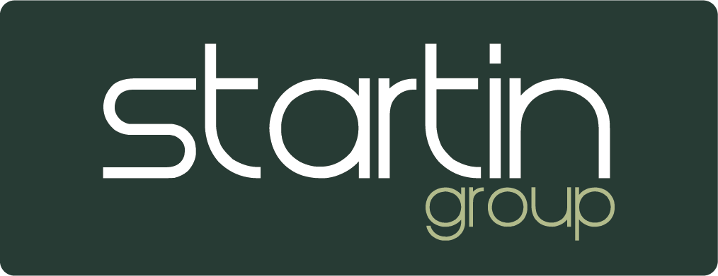

Auction only trade policy

All trade cars must be disposed of through our partner auction house Wilsons Car Auctions.

All vehicles should go through Wilson Car Auctions a minimum of 3 times. If a vehicle does not sell after the 3rd time our second-string Dealer Auction/Arrow Auction must be used.

If the vehicle still does not sell the Head of Business can authorise an alternative route.

Under no circumstances will we tolerate an unauthorised deviation to the above as this policy is in place to limit the business and its employee’s exposure to fraudulent activity.

If in doubt speak with your Head of Business, Used Car Buyer, or Head Office.

