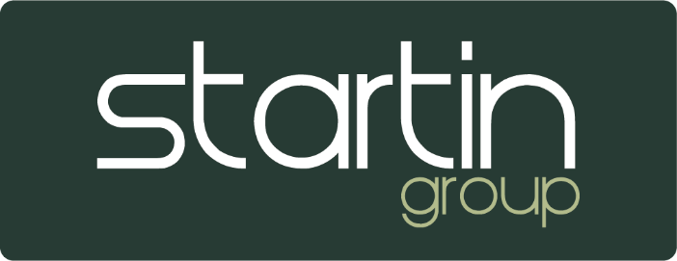

Payment requests

- Complete the payment request form filling in all of the top section
- Tick the relevant boxes in the payment type section to confirm all sections have been completed and relevant paperwork attached. If not applicable please put N/A in the box.
- Please note all payments require Manager and HOB signature.
- Vehicle payments over £50k require HOB and Director signature. These are highlighted by a * on the payment request.
- Head office will reject any payment request with missing information.
- Admin are to ensure daybooks are printed before sending the request.
- Confirmation of bank details must be sent in the form of details on headed paper, an email from the customer, a copy of a bank statement or photocopy of a debit card (before scanning customer card details please use card scanning wallets provided)
- Send to payments@startingroup.co.uk by 2pm. Head Office will aim to process payments within a 24-hour period.
- Email subject should be in the following format ‘Payment Request – Mrs Smith Cashback’
- If the payment is urgent the Email Subject should be in the following format ‘Urgent Payment Request – LCVR'. However, no guarantee can be made that urgent payments will be processed sooner than 24hrs
- The payment request is in an editable PDF Format please type information instead of hand writing.
- Where possible limit the number of documents printed and directly attach to the email instead.
- Please do not send directly from the scanner. Send them to yourself and then email to accounts.
- Payments processed are recorded on the shared document titled ‘2024 TTBACSCHQ Payments’ spreadsheet for you to access. Access can be granted via your Accountant. This spreadsheet acts as your confirmation Head Office have received and processed the payment successfully.

Updated 2023

